Light Knowledge Organiser
KS2
Glossary
light | The brightness that lets you see things. It comes from a source
source | The place that light comes from
reflect | When light ‘bounces back’ off a surface
visible | Something that can be seen. The antonym is ‘invisible’
ray | Narrow beams of light
beam | A line of light energy that travels in a particular direction
pupil | The small black hole in the centre of your eye
retina | The area at the back of your eye that receives the image and then sends it to your brain
opaque | A material that you cannot see through
translucent | A material that you can see through a little bit
transparent | A material that you can see through
shadow | A dark shape on a surface that is made when something stands between the light source and the surface
illuminate | When light lands on a surface
light energy | The power that light carries
filter | A device that stops some things travelling through it. A light filter stops certain frequencies of light traveling through it. It is usually coloured.
absorb | To soak up or take in
refract | When a beam of light changes direction, for example, when it enters water or glass
Key facts
We need light to see things |  | A shadow is formed when something blocks part of a beam of light
The visible spectrum is the name for the light that we can see, and is made up of the colours of the rainbow.  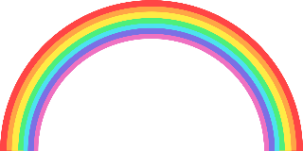 |  | A beam of light can change direction when it hits an object  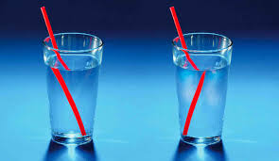
Light always travels in straight lines |  | Dark is where there isn’t any light
Light is reflected off surfaces. Some surfaces absorb more of the light energy than others. This depends on if they are opaque, translucent of transparent |  | We can see objects because light reflects off them and the beam of light travels in to our retina. The retina sends the image to our brain. 