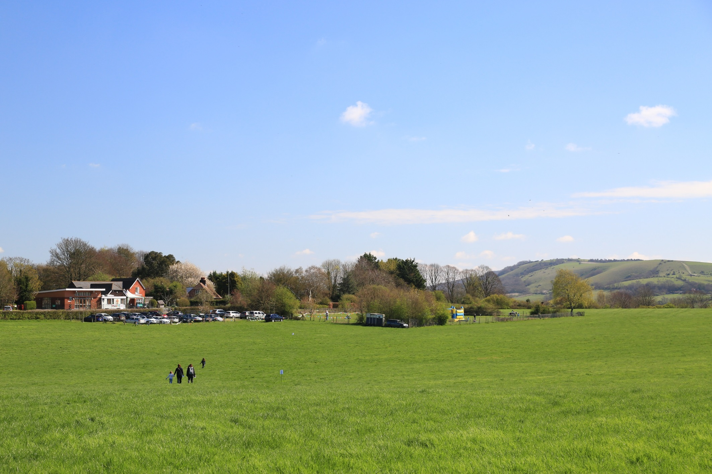

**SENDCo**

**Rachel Seymour**

Mid-Day Meals

**Jill Maynard (Lead + 1st Aider)**

**Kim Thompson**

Other Adults Incl. Students

Other Adults Incl. Students

Teaching Assistant

First Aid (including paediatric)

Managing Medicines

**Christine Rowland**

**Sarah Organ**

**YR/1 Teacher**

Early Years / Phonics

Maths

**Rachel Seymour**

Deputy Safeguarding Lead

ICT Technician

**Chris / JSPC**

Teaching Assistant

Sport Specialist

**Sammy Hetherington**

**Y2/3/4 Teacher**

Multiplication Check & KS1

Science / PE

**Katie Willett**

Other Adults Incl. Students

Learning Support

Team Teach

**Dagmar Heseltine**

**Y5/6 Teacher**

KS2 SATs / Transition

English

**Laura Braun**

**HLTA**

Outdoor First Aider

Bury Rangers

**Giles Gatrell**

**Headteacher**

Designated Safeguarding Lead

Child Looked After Lead

**Thomas Moore**

**Business Manager**

Premises Manager

**Deborah Clark**

1st Aider

Deputy Safeguarding Lead

SEN TA Autism

Dyslexia Awareness

ABA Specialist

**Dagmar Heseltine**

Little Birds Nursery

Governor Link - S Fane & S McConachie

**The Church of England**

Father Peter Mallinson

**BUZZARDS**

**SPARROWHAWKS**

**KESTRELS**

**West Sussex LA**

Bury CE Primary School

STAFFING STRUCTURE 2020/2021

**The Governing Body**

**Class Teacher 0.3**

RE

**Charlotte Gammon**

**Chartered College**

National Small School Support Network

Subject Experts

National Trust/SDNP/ Jonny Mott

**Managing Medicines**

Admissions

School Visits

Deputy Safeguarding Lead

**Deborah Clark**

Caretaking and Cleaning

**Jill Maynard**

Learning Support AM

Outdoor First Aider

**Giles Gatrell**