Bury Rangers Plan
Natural Art Autumn 2018
Why are we doing this?
Previously the children have studied sculptors who use natural materials and nature as a stimulus. In this unit they will look at an artist and designer who used nature as a stimulus and natural inks to create his work. The children will be able to replicate his work using similar techniques in our woodland.
Curriculum areas covered.
KS1 | English | Maths | Science | Art | DT | History | Geography | PE | PSCHE | MFL | RE | Computing | Music
KS2 | English | Maths | Science | Art | DT | History | Geography | PE | PSCHE | MFL | RE | Computing | Music

Art KS1 | Art KS2
Use a range of materials to design and create products | Develop techniques including control of materials, experimenting, and an increasing awareness of different kinds of art, craft and design.
Use painting to share their ideas, experiences and imagination | Use sketch books to record observations and use them to revisit and review ideas
Develop a wide range of techniques in using colour, pattern, texture, line shape and form | Improve mastery of art and design techniques including drawing and painting with pencil charcoal paint.
Learn about a range of artists, craft makers and designers, describing the similarities and differences and making links to their own work. | Learn about great artists, architects and designers in history.

History KS1
Learn about the lives of significant individuals who have contributed to national and international achievements

Learning activities
At the end of this unit the children will have created:
KS1 and KS2
Make ink from blackberries, elderberries, oak galls
Make paint from nettles
Make charcoal
Learn about William Morris
Design own William Morris motif linked to our woodland
Paint motif using natural paints in sketchbook and on wooden disks.

Cross Content vocabulary
compare | contribute | explore | symbol
contrast | design | illustrate
create | evaluate | represent

Knowledge Organiser – Natural Art
Glossary
charcoal | A kind of pencil made from burnt wood –usually charcoal. It creates a black or grey colour.
oak gall | A large, round, lump found on oak trees. A Gall wasp lays an egg into an acorn and as it grows the acorn becomes deformed. Sometimes they are called 'Oak Apples'.
pestle and mortar | A bowl and stick made of clay. They are used to grind down ingredients for cooking and for making ink, paint and stains.
motif | A clear simple design that an artist or designer uses repeatedly.
Arts and Crafts movement | A group of artists, craftspeople and designers who worked in the 1860s and 1870s. They wanted to design things in a way that didn’t damage the people who made them or the environment. Their designs were simple, clear and often based on nature.
William Morris |  | Key information
William Morris (24 March 1834 – 3 October 1896) was a famous Arts and Crafts artist. He is most famous for designing fabric and wallpaper with clear repeated motifs. He also designed furniture and houses. He thought that old buildings should be protected and preserved for the future. He was most famous in his lifetime as a poet and not a designer. |  | 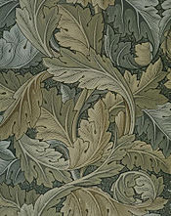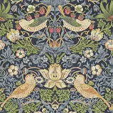  William Morris designs including 'Strawberry Thief'
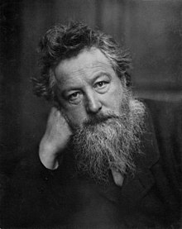  William Morris |  | 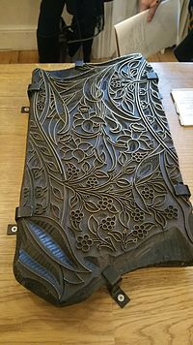  A wooden printing block that Morris used to print his wallpaper designs
Key Information
Natural inks can be made from plants by crushing them up or squeezing them. |  | Charcoal can be made by putting it in a metal box with some holes to let air in, on a fire.
Sometimes you need to add a 'binder' like egg yolk or flour to make the ink thick enough to use as paint.  Willow makes good charcoal |  | William Morris used natural dyes and paints for his work.
William Morris used 'motifs' and repeated them in a pattern in his paintings, fabric and wallpaper. |  | William Morris was part of a movement called 'Arts and Crafts' who liked to use nature as a stimulus

See National Curriculum coverage document for how this unit fits with the rest of our curriculum.

