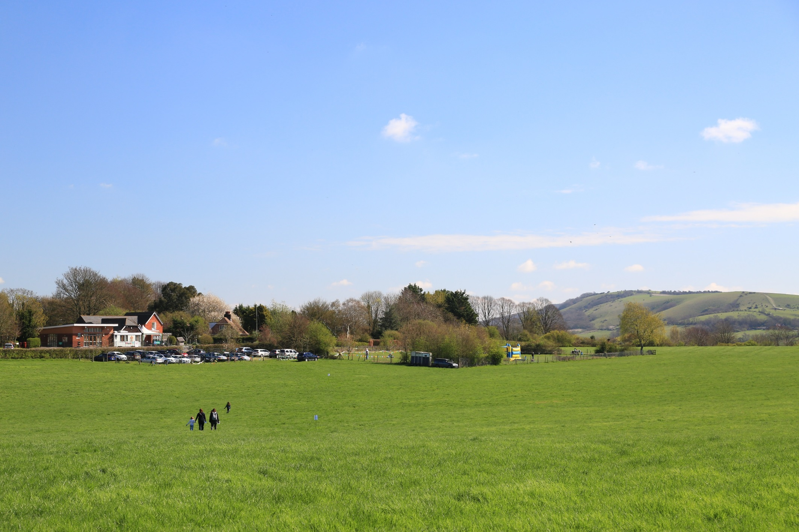

**SENDCo**

**Julia Edwards**

**Wednesday AM**

Mid-Day Meals

**Jill Maynard (Lead)**

**Kim Thompson**

**Becky Atkinson** (Chartwells)

Other Adults Incl. Students

Other Adults Incl. Students

Learning Support

First Aid (including pediatric)

Managing Medicines

**Christine Rowland**

**Sarah Organ**

**YR/1/2 Teacher**

Early Years / Phonics / KS1 SATs

Religious Education

**Charlotte Gammon**

ICT Technician

**Chris / JSPC**

Learning Support

ABA Specialist

**Sadie Perkins-Taylor**

**Y3/4 Teacher**

Lauren Burelli

Other Adults Incl. Students

Learning Support

First Aider

**Giles Gatrell**

**Y5/6 Teacher**

KS2 SATs / Transition

English / Computing / Art

Mentor

**Laura Braun**

Learning Support

Outdoor First Aider

Bury Rangers

**Giles Gatrell**

**Headteacher**

Designated Safeguarding Lead

Maths*

**Thomas Moore**

External Providers

WS Music/National Trust/SDNP

**Business Manager**

Premises Manager

**Deborah Clark**

Managing Medicines

Admissions

School Visits

Deputy Safeguarding Lead

**Deborah Clark**

Caretaking and Cleaning

**Jill Maynard**

SEN TA

Dyslexia Awareness

ABA Specialist

Mornings only

**Dagmar Heseltine**

(Little Birds Nursery)

Opening September 2018

**The Church of England**

Father Peter Mallinson

**BUZZARDS**

**SPARROWHAWKS**

**KESTRELS**

Bury CE Primary School

STAFFING STRUCTURE 2018/2019

**The Governing Body**

**West Sussex LA**

Class Teacher

Maths

**Katie Willett (Maternity)**

**Chartered College**

National Small School Support Network

Volunteer teacher

Lucy Brownbill